Today’s key technical levels in equities, rates, currencies, and commodities.
For best results in Word, click View tab then click Web Layout



Friday, February 9 2018

TODAY’S GAME PLAN:

EQUITIES | Everyone looking at the 200dma in SPX (2538) and that will be key to see reaction during day session. Sell the rallies mentality short term. ESH has 2571/73 area (.786 s/t) as initial pivotal pt support today. Small caps outperform; spot R2000 settles on 200dma and RTY may play catch up once this breaks. DAX and Eurostoxx weigh even with dollar strength. Eurostoxx banks starting to weigh as well. China weighs.
RATES | USH holding initial support of 143-20; use as pivotal today. Some lift likely as equities weigh again. Bund holds initial target and key support a positive for now. TYH has 121-10 as initial key resist today.
ENERGY | CLH8 is almost down -10% from its high; $60 will be pivotal. Stay short, cover some around here or play for a s/t lift, but need equities to firm. Nat Gas has 2.50* area as long term major support.
METALS | Gold is negative to mixed. Held initial support of 1309 yest. Dollar is key here; silver underperforming is a negative. Copper rolling over, neg below 3.09 today looking for 3.025. Copper neg to gold.
CURRENCIES | US$ is nearing its initial key of 90.750*. look for pause there. EURUSD negative below 1.2300 for now; 1.2169* pivotal support. CA6 has 79065 (.618) pivotal s/t; momentum below. DA6 has 7742 (200dma) pivotal support area.
TRADE IDEAS:
New Ideas:
Date | Commodity |  | Buy | Sell | Stop | Target | Notes
9-Feb | ESH |  |  | 2617/19 | 2625 |  | Initial resist
 | ESH |  | 2571/73 |  | 2568 |  | use as pivot pt area
 | CLH |  | 60.05 |  | 59.8 |  | s/t trade -10% bounce
 | ESH |  | 2530/35 |  | 2520 | 2600 | day session 200dma
*ACTIVE TRADE IDEAS*
Date |  | Commodity | Long | Short | Stop | Target | Notes
2/7/2018 |  | DXH8 | 89.60 |  | 89.00 | 91.50 | held l/t support
2/7/2018 |  | SIH8 |  | 16.42 | 16.51 | 16.07 | below cloud
2/6/2018 |  | CLH8 |  | 63.90 | 64.50 | 60.00 | $60 is -10% from high
2/6/2018 |  | USH8 |  | 147-20* | 148.02 | lower | Covered some
DATA and HIGHLIGHTS:
US Budget Bill Has Been Passed Averting Govt Shutdown. UPS, FEDEX sink in pre-market as Amazon said to explore delivery service. Crude futures to begin trading in Shanghai on March 26: CSRC link . Theresa May continues to hold a firm line on Brexit negotiations.
 | ESH8 | TYH8 | GCJ8 | CLH8 | DXH8
Resistance | 2669.50 | 123-08+* | 1370.5 | 66.05 | 93.370
 | 2650/52 | 122-23+ | 1357.0 | 65.29* | 93.000
 | 2634.50* | 122-05 | 1348.0 | 64.22* | 92.275*
 | 2617/19 | 121-23 | 1340.0 | 63.63 | 91.500
 | 2609.00 | 121-10 | 1332.0 | 62.70 | 90.740*
Settlement | 2593.50 | 120-28+ | 1319.0 | 61.15 | 90.116
 | 2593/95 | 120-18 | 1309.0 | 61.05 | 89.700*
 | 2571/73* | 119-28* | 1301.9 | 60.00* | 89.230
 | 2542.00 | 119-10/12 | 1291.0* | 59.26 | 88.900
 | 2529/35* | 119-00 | 1270.0 | 58.00/23* | 88.250
Support | 2504.25 | 117-17* | 1265.5* | 57.15 | 87.100
Colors within the report: Green is always the 200 period (day, week, etc.). Red is always 21, Blue = 50, Brown = 100, Yellow is vwap. *Stars have more emphasis, meaning 2 or more technical pts line up
EQUITIES: 1 week outflows from US equity ETFs (-$23B); SVXY (inverse Volatility) AUM on Monday $97mm, $690mm yesterday. Just two weeks ago equity funds had record high inflow, and this week it’s the largest equity outflow on record.
This is the first chart I look at every day. The PIS (passive investment strategy) using the long bond and E-Mini S&P futures. We had our eye on this all last year along with TLT+SPY, TY+ES, etc. On January 26th and 29th it was testing the top of the trend channel and our thought was to look for a pullback of some sort. When it broke the bottom of the trend channel on February 2nd, somewhat surprisingly it was stocks leading the decline. It will remain negative with settles below the 200dma and the downside targets are discussed in the tactical section in this letter.
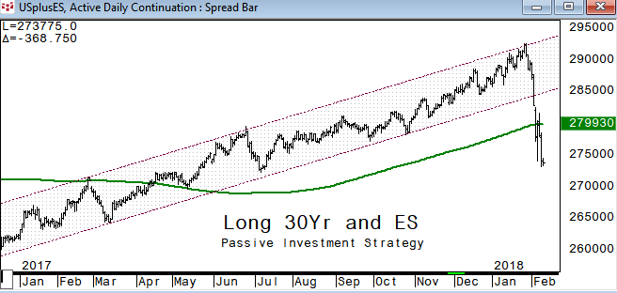
ESH8: held its 200dma on the Monday night plunge and we are looking for a test of the 200dma in SPX (2538) to see how it reacts during the liquid day session trade. 2571 is the .786 retrace of the recent bounce in ESH and will be pivotal support today.
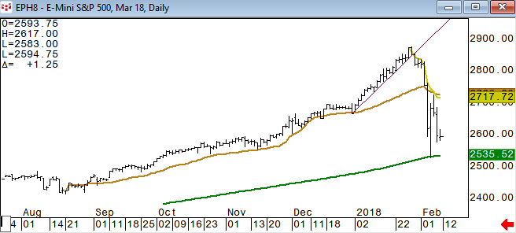
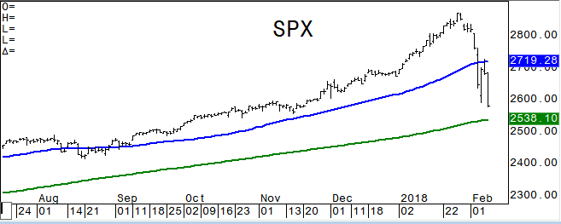
SPX rallied nearly back half way back of the recent decline, tested the 50dma and seems likely to give a test of its 200dma.
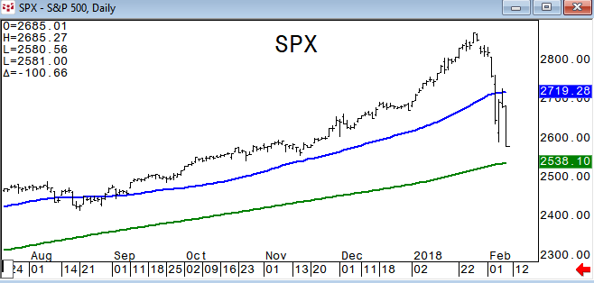
QQQ broke its 100dma which has been very pivotal support for over a year. Could see it lift back above it, but looking for the 200dma at 148.15* next. NQH settled below its 100dma of 6383; 6090 is the 200dma in NQH.
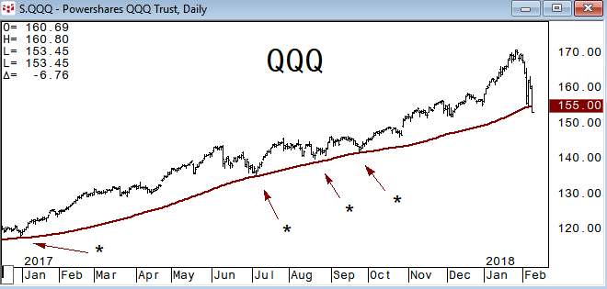
Spot Russell 2000 Index held its 200dma on the low this week, but quickly right back to it. IWM settled on its 200dma.
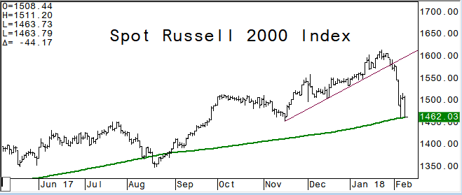
NYSE Composite Index has its 200dma at 12200.
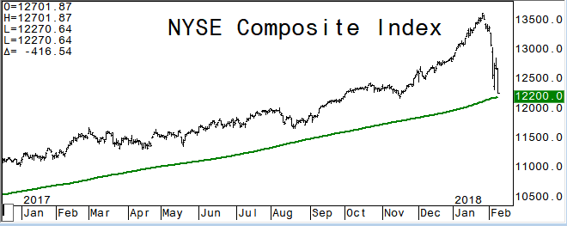
This is what happens when there is no rotation. The current environment is seeing defensive and interest rate sensitive sectors falling as well. XLU settles on its weekly trend line and 200 week moving average.
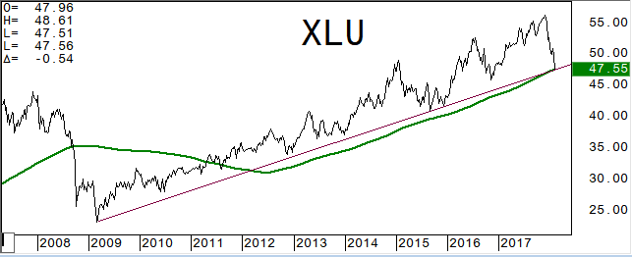
Consumer Staples Sector ETF, XLP, fell back below its 200dma and holding below it since.
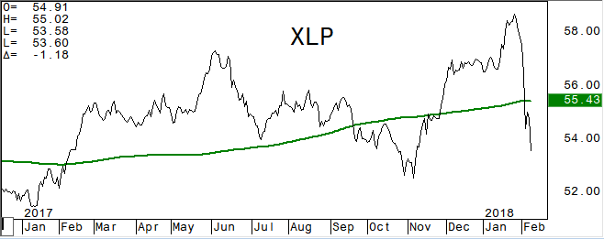
Biotech had been a market leader this year and IBB has fallen -12% from its closing high. Some room before it would test what has been a very pivotal closing pivot line.
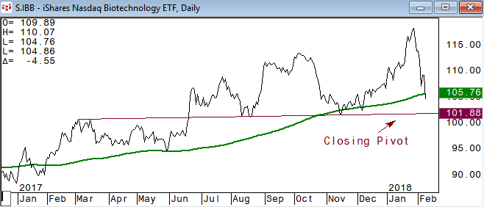
High Yield ETF has been weakening since November when it broke its 200dma and held below it the first week of this year. -3.15% from the Jan high and has 84.50 as next support.
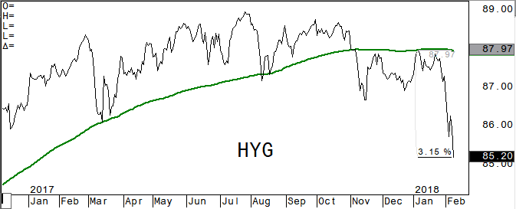
DAX future is holding a negative tone below its 200dma which has been a very good closing pivotal pt. 11722 is the .382 retrace from the 2016 low. March Eurostoxx has 3298 as long term .382 retrace and key support.
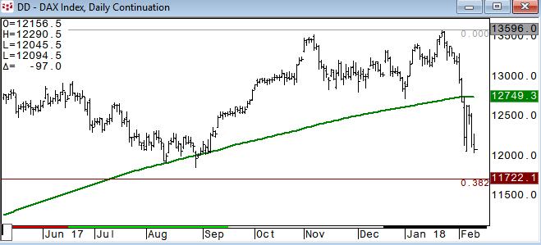
Eurostoxx Banks Index is turning lower after testing the .786 (potential reversal) resistance and is back below its 200dma of 133.5. The 200 day was broken in early January for two days before firming back above it and this will be the first close below it since then, which was first time since October ’16).
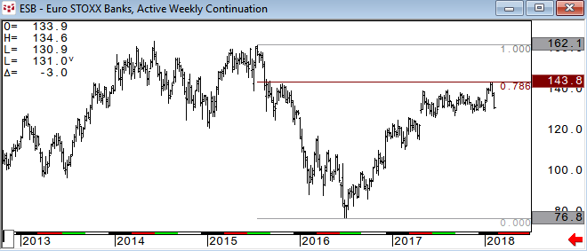
The Shanghai Composite broke its 200dma yesterday and fell -14.5% from the Jan high before lifting a bit in the last hour.
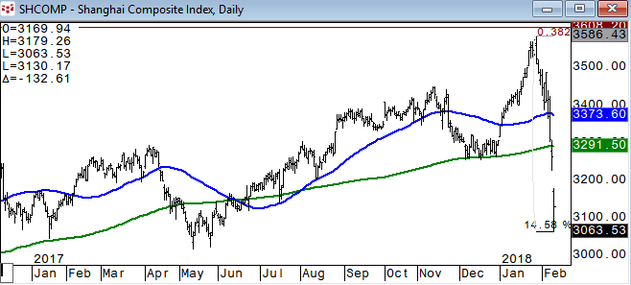
TACTICAL ALLOCATION: RELATIVE VALUE/STRENGTH
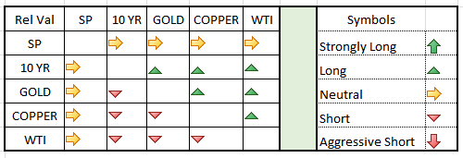
This is the relative strength, pairs trade section. Many times looking at a certain commodity relative to another can give you a perspective that you just cannot get looking at the individual. Even if you don’t trade pairs, looking at your market this way can be valuable. The above reads vertical column relative to horizontal. Crude Oil starting to turn negative relative to other asset classes in short term view.
PASSIVE INVESTMENT STRATEGY: The TLT+SPY version had multiple tests and holds of the yearlong trend line. The weekly chart in TLT+SPY shows we have another -9.5% before the PIS gets to the weekly trend line at current levels. If both continue to slide, that could happen sooner than later. If treasuries start to firm because of equity weakness, it will take a while longer.
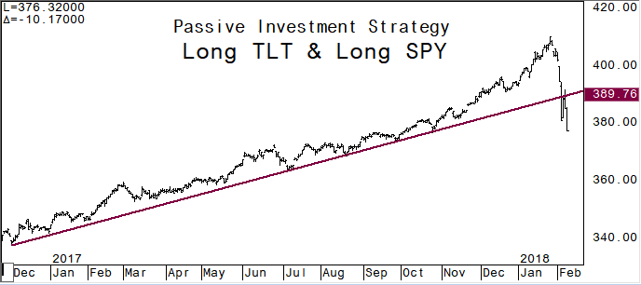
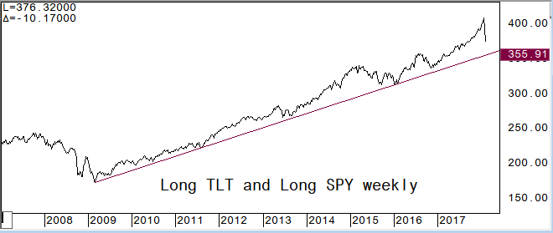
This is long TLT and short SPY. A breakout above the trend line would likely mean stocks are weakening further and then we have to gauge the momentum. At this stage it would be very unlikely that treasuries outperform while both move higher… As this holds we can see equities lift.
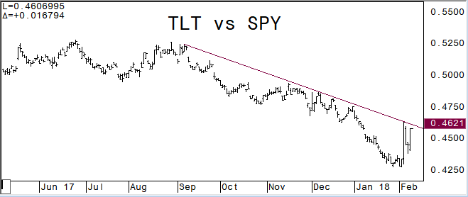
Two other instances of sharp declines were the August 2015 China currency devalue and the 2010 Flash Crash. Both times there was an initial bounce, choppiness, and then retest or break of the plunge lows. These things usually don’t just end quickly.
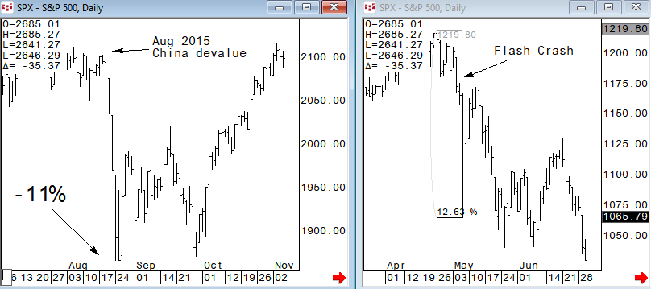
Copper remains negative relative to Gold as it holds below the 100dma pivotal pt in the pair
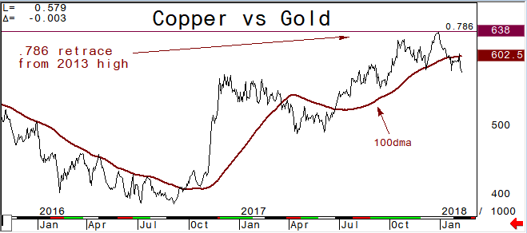
FIXED INCOME:
TYH remains negative overall below its 200 week moving average and has an extension target of 117-17.
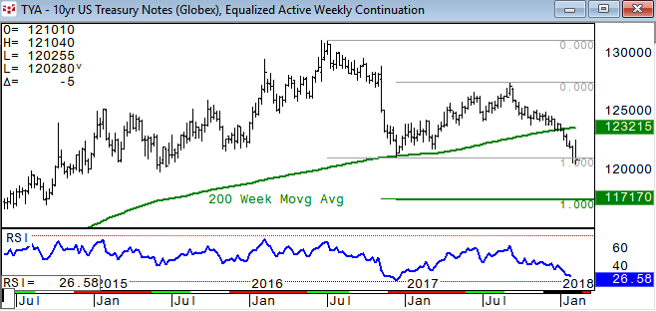
10 year yield is holding above the Dec ’16 high and likely to test 3% soon; highest level in yield since Jan ‘14
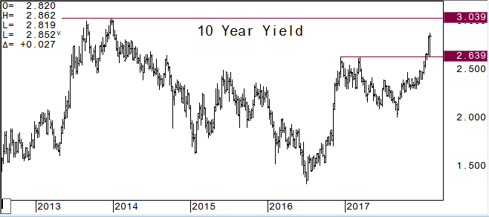
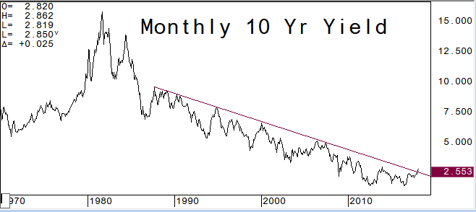
USH8: remains negative after breaking its 200 week moving average which had been very pivotal support. Next supports at 143-17/20, 142-04*. 30 year yield likely to see 3.25%
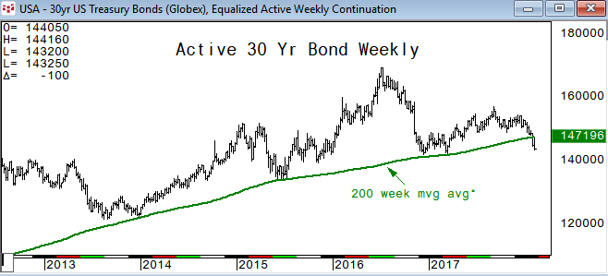
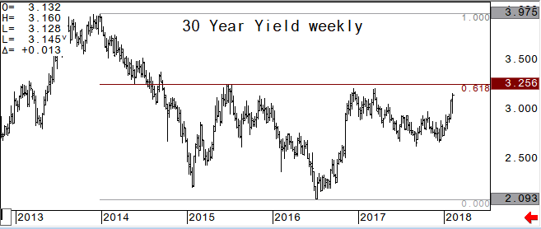
2/10 yield curve is likely to steepen further as it climbs above its 100dma which had been pivotal resistance
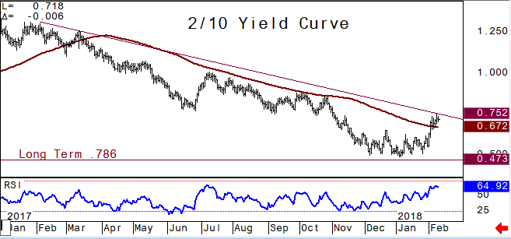
Bund future holds the 157.28 area yesterday
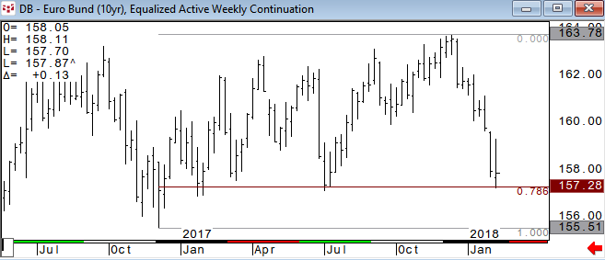
ENERGY: Global equity rout starts to weigh on crude oil; Iran announced yesterday that is plans to increase production within the next four years by at least 700,000 bpd.
March Crude Oil: top chart is the monthly view of the rolling front month contract. Using the 200 month moving average as an area of resistance. We liked being short from the $64 area and took some profits above the 50dma initial target. $60 would be a -10% decline from the 66.66 high which should act as support
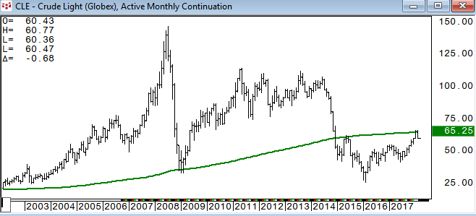
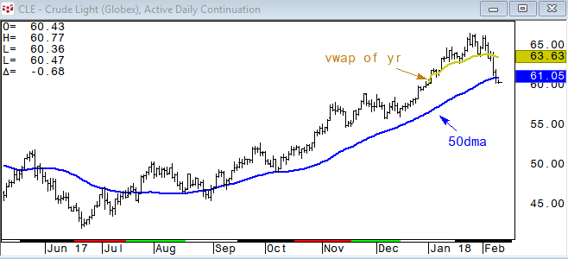
March RBOB: look for the .786 retracement area to hold for now…
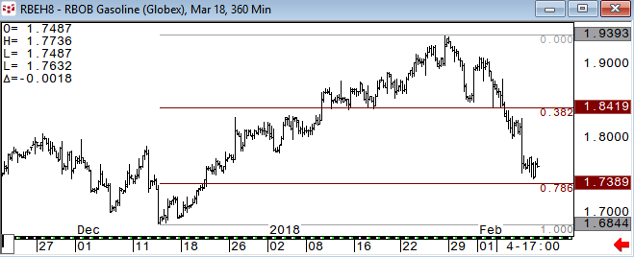
March Nat Gas breaks the short term .786 support today (held the last three days) and seems likely to give another test of the longer term
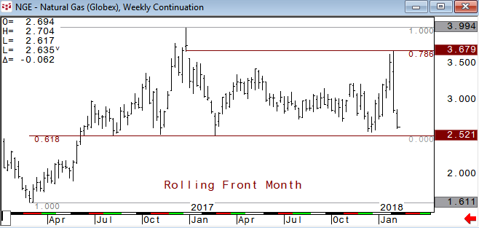
METALS:
April Gold – gold has not seen any strength on the equity weakness and risk off theme as higher global rates theme and stronger dollar weighs. A settle below 1318 (vwap) might indicate more downside momentum.
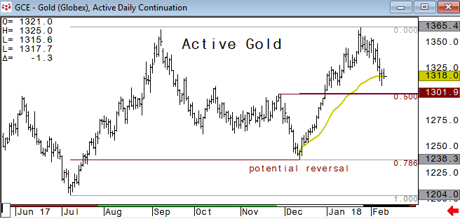
March Silver (as active contract): is holding below the .618 retrace, but not much downside momentum. 16.425/16.510 area is short term resistance area.
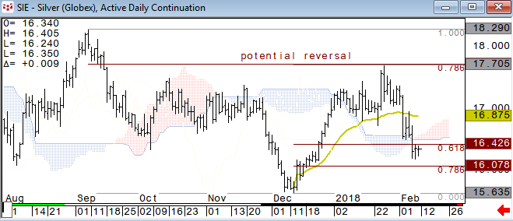
Gold vs Silver*: normally we would look for silver to be the lead in direction. The .786 retrace had been very pivotal resistance and negative for both gold and silver above the .786.
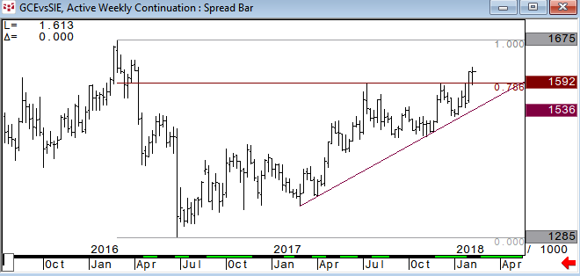
March Copper: lower again today and has 3.0250 as next support with a break of this level likely to retest the 200dma
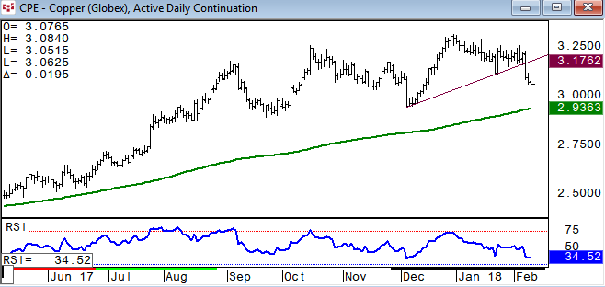
CURRENCIES:
US$ Index: after holding the 200 month moving average and 50% retrace from the May 2011 low the US$ Index is seeing a bit of a lift this week. Look for 90.740 to be tested and use as s/t pivotal pt resistance.
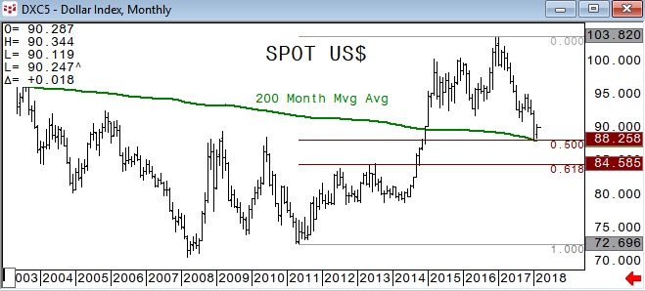
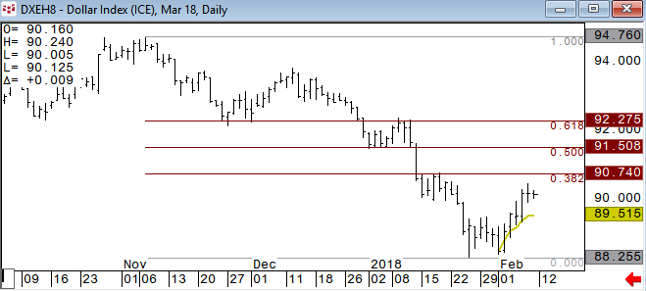
CNH: the dollar is weaker against the China Yuan after firming yesterday on trade data
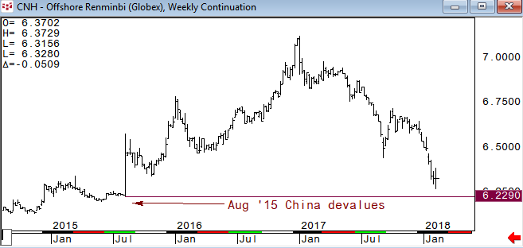
Spot EURUSD found resistance in front of the long term .618 retrace and pulls back about 50% of the year . Remains negative s/t below 1.2300 for now.
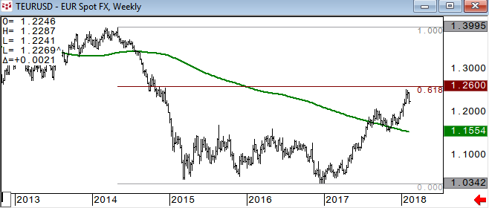
CA6 fell back to the 50dma which has been a decent s/t closing pivotal pt; use the .618 retrace which lines up with the Nov and Dec highs as key support.
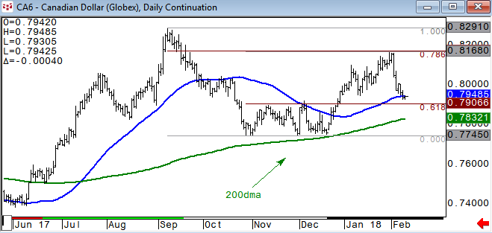

Charted using CQG
www.cqg.com

DISCLAIMER: For Educational purposes only. This is not a solicitation to buy or sell commodity futures or options on commodity futures and should not be construed as such. The risk of trading securities, futures and options can be substantial and is not for everyone. Such investments may not be appropriate for the recipient. The valuation of futures and options may fluctuate, and, as a result, clients may lose more than their original investment. Nothing contained in this message may be construed as an express or an implied promise, guarantee or implication by, of, or from Keystone Charts, Inc. that you will profit or that losses can or will be limited in any manner whatsoever. Past performance is not necessarily indicative of future results. Although care has been taken to assure the accuracy, completeness and reliability of the information contained herein, Keystone Charts, Inc. makes no warranty, express or implied, or assumes any legal liability or responsibility for the accuracy, completeness, reliability or usefulness of any information, product, service or process disclosed. PROPERTY OF KEYSTONE CHARTS, INC. DO NOT COPY OR FORWARD INTELLECTUAL PROPERTY WITHOUT PRIOR WRITTEN CONSENT.

