Today’s key technical levels in equities, rates, currencies, and commodities.
For best results in Word, click View tab then click Web Layout



Friday, February 2, 2018

The Week in Review, What Can Derail Equities?
It is pretty much understood that a weaker dollar is the goal of this administration. PIMCO (LINK) wrote that the U.S. is fighting, and winning a “cold currency war.” European Central Bank Executive Board member Benoit Coeure warned this week that volatility in foreign-exchange markets could lead to an “unwarranted tightening” of monetary policy that the bank would have to “reassess and consider.” For now President Trump is having his way, as higher US rates have not lifted the dollar. But, how low can it go before we really hear it from China? This chart is the US$/Chinese Renminbi Offshore or CNH (futures shown), and it is back to where China devalued their currency back in 2015. That led to a 20bp rally in 10 year yield and an -11% drop in the S&P. On Monday an official from China's National Development and Reform Commission wrote that a black swan or grey rhino (high-impact events) were likely to take place this year - Reuter’s link. The Shanghai Composite Index has fallen roughly -4% from Monday’s high. If CNH continues to decline next week, we need to be on guard for more rhetoric from China that could potentially spook equities.
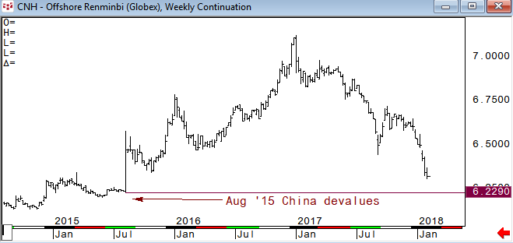
Immediately after the November ’16 US Presidential election small caps (IWM) outperformed sharply relative to the S&P 500. Then in the first half of 2017 small caps underperformed. What's interesting is the .618 Fibonacci retracement in IWM vs SPY is also the same spot as that Nov ’16 turning point. And, it held nicely in August for a bounce. Well, we are back there again this week as small caps have outperformed this year. This will be key for the week ahead. If IWM/SPY holds, we will likely see rotation higher. If it breaks, small caps will likely lead the other indices lower.
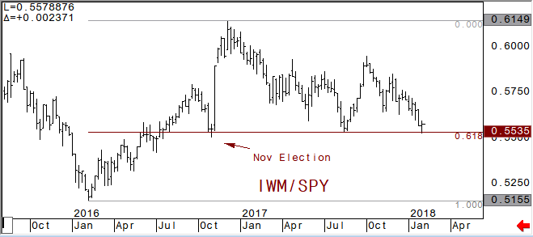
Rotational plays have been the theme for most of 2016 and all of 2017 which has been bullish. It will be interesting to see if this continues this year. If not, it will likely be a bearish signal. With higher interest rates one rotational play would probably be into banks and financials. The S&P Bank ETF relative to the S&P 500 Index shows a similar patter as IWM/SPY in that the .618 retracement held perfectly. Now we are looking for a momentum breakout of either side of the triangle formation. Banks outperforming the broader index from here would likely mean that the yield curve starts to steepen. Bear steepening might just be a headwind for stocks overall if the 30 year yield rises too quickly.
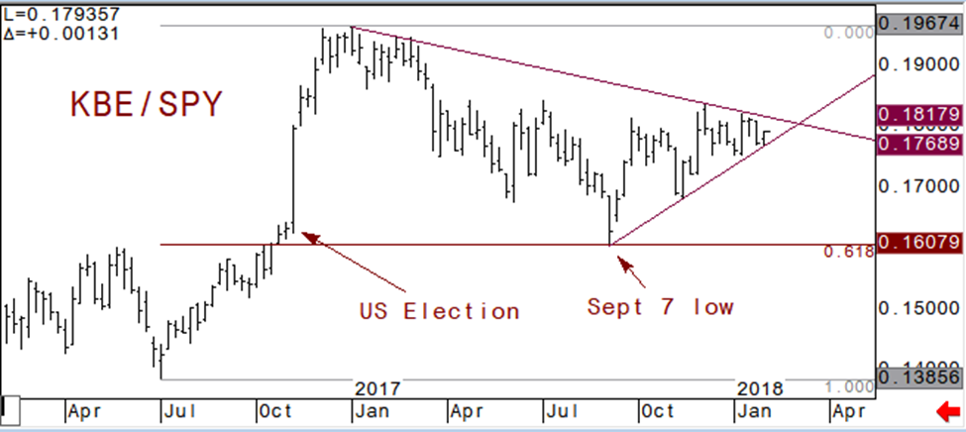
In December the 5 year note future broke its 200 week moving average for the first time since August of 2007. Then in the second week of January the 10 year future broke its 200 week. Once broken, neither was able to trade back above, and have been leaking ever since. This week, the 30 year future is breaking its 200 week moving average and as you can see from the chart; this has been very pivotal support over the last few years. We can expect similar downside momentum in the 30 year, just like the 5 and 10.
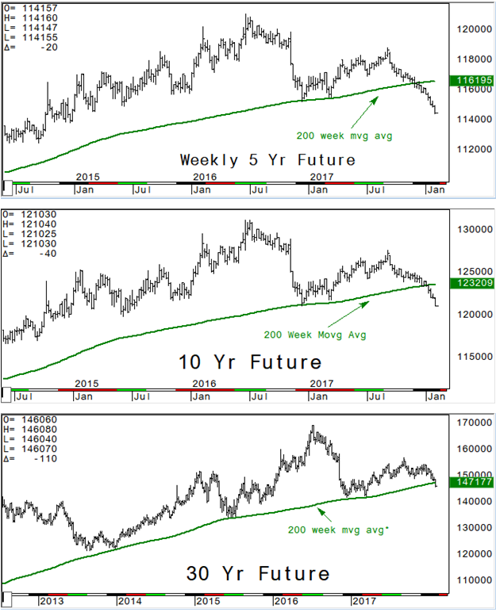
For most of 2017 gold and 10 year futures traded directionally in tandem. Then in mid-December they began to diverge. What happened? Technically the TY vs Gold pair hit a pivotal resistance level at the .786 retracement (see chart two below). I like to use the .786’s as potential reversal levels and it certainly worked here. The weaker dollar has been an influence for sure, especially the dollar vs China’s Renminbi (CNH).
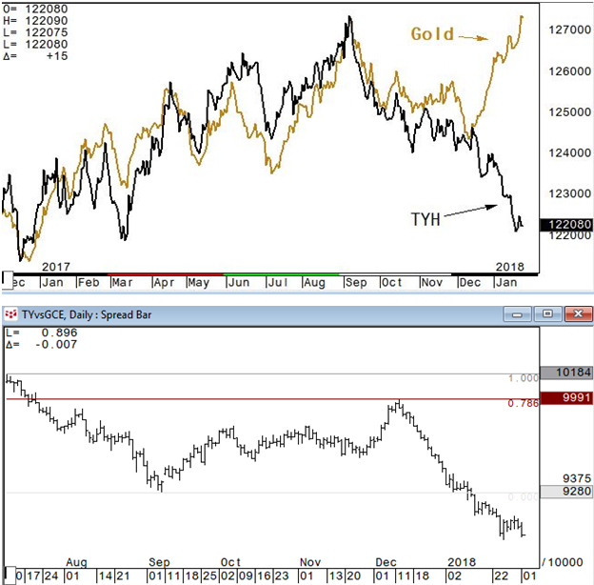
This chart displays the passive investment strategy using 30 year futures and E-Mini SP. Being long both bonds and the S&P Index has trended higher since the March ’09 lows and held within this channel for over a year. Bonds are steadily moving lower and appear to be weighing on equities a bit. Monday marked the top of the trend channel on this chart and there is still some room before it would test the lower band of the channel. A break of the lower support line would likely see stocks become vulnerable to a real pullback as passive investors will suddenly feel some pressure.
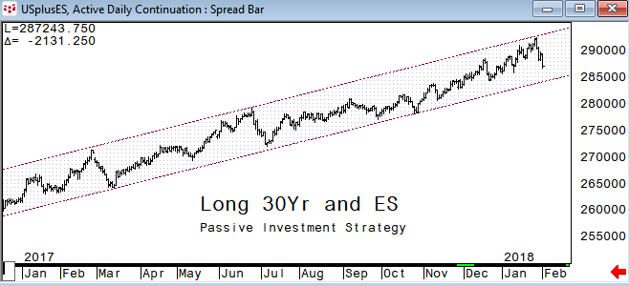
Crude Oil futures have rallied +58% from the June low and XLE has had a nice run, +26% from its August lows at its recent high. The January 24th high in XLE is just a few cents away from the Dec ’16 top and seen as pivotal. The energy sector went from crowded short for most of 2017 to crowded long now. So, it looks like some rotation out of energy this week after XLE/SPY hits what has been a very pivotal level in this pair. Notice the January ’16 low is the recent top. Using this pivot line we would look for upside momentum of some magnitude once above it.
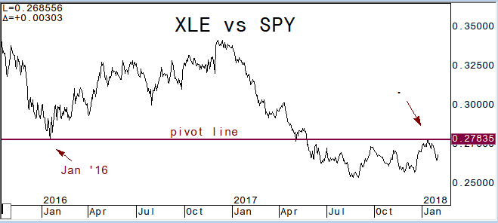
Bitcoin has been a retail phenomenon as institutional traders have been reluctant to join this party. Just as rotation has been bullish in equities, There has been rotation between crypto currencies until recently. When Bitcoin dropped over 40% in December other cryptos rallied such as Ripple, Ethereum, Litecoin, etc. When these fell, Bitcoin rallied. Well, that seems to have changed recently. The Bitcoin Real Time Index broke its 50dma in mid-January and this week it broke its 100dma for the first time in quite a while. Currently filling the gap from November may be a positive, but if this breaks we can look for a test of the 200dma at 6200 area.
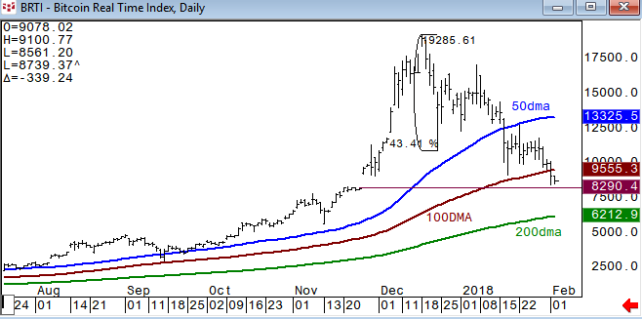
David Wienke is the editor of Keystone Charts link. More than 30 years’ experience providing technical analysis and execution services to institutional clients is now provided in a daily newsletter, The Daily Game Plan. Coverage includes equities, rates, currencies, and commodities. Dave is also an introducing broker with Capital Trading Group, LLLP (CTG); a Chicago based investment firm focusing on alternative investment opportunities for CTAs and individual investors. Charts are created using CQG, the best charting service there is. For a free trial of the Daily Game Plan newsletter go to www.keystonecharts.net or email me at dave@keystonecharts.net

Charted using CQG
www.cqg.com

DISCLAIMER: For Educational purposes only. This is not a solicitation to buy or sell commodity futures or options on commodity futures and should not be construed as such. The risk of trading securities, futures and options can be substantial and is not for everyone. Such investments may not be appropriate for the recipient. The valuation of futures and options may fluctuate, and, as a result, clients may lose more than their original investment. Nothing contained in this message may be construed as an express or an implied promise, guarantee or implication by, of, or from Keystone Charts, Inc. that you will profit or that losses can or will be limited in any manner whatsoever. Past performance is not necessarily indicative of future results. Although care has been taken to assure the accuracy, completeness and reliability of the information contained herein, Keystone Charts, Inc. makes no warranty, express or implied, or assumes any legal liability or responsibility for the accuracy, completeness, reliability or usefulness of any information, product, service or process disclosed. PROPERTY OF KEYSTONE CHARTS, INC. DO NOT COPY OR FORWARD INTELLECTUAL PROPERTY WITHOUT PRIOR WRITTEN CONSENT.

