Today’s key technical levels in equities, rates, currencies, and commodities.
For best results in Word, click View tab then click Web Layout



February 7, 2018

TODAY’S GAME PLAN:

EQUITIES | SPX retraced .382 of recent decline at 2700 and using as pivotal pt for now. ESH has 2677 session vwap as initial key. Looking for SPX to give a test of its 200dma, but could see momentum above 2700. Positives: QQQ held pivotal support and R2000 Index spot holds its 200dma, and ESH held its 200dma. NQH would likely see some weakness today below 6560. Key s/t resistance at 6747.
RATES | USH8 touched key resist and looking for next leg lower move; a break of 145-15 area (s/t .618) would see some downside momentum potential. TYH has 121-00 (s/t .786) as initial key support today. Neg below 121-23 today.
ENERGY | CLH8 is negative short term below 64.50 area and 62.63* initial key support, looking for $61 area. Commodity Index holds long term resistance area.
METALS | Gold is vulnerable and a break of 1317-22 area should see momentum. SIH has 16.425 as s/t pivotal support and would lead lower below it. Copper may slip below 3.1650 tl
CURRENCIES | US$ is positive s/t above 89.280 looking for 90.740, but will be choppy. GBPUSD has 1.3850 area as pivotal support. USDCAD should test 50dma at 1.2602 and use as pivotal pt. EU6 has 1.23425 (.382) as pivotal support with momentum potential below it.
TRADE IDEAS:
New Ideas:
Date | Commodity |  | Buy | Sell | Stop | Target | Notes
7-Feb | DXH8 |  | 89.40 |  | 89.00 | 91.50 | held l/t support
 | SIH8 |  |  | * | <16.42 | 16.07 | 0.618
 | Long Gold/Silver |  |  |  |  |  | above key .786
 | ESH |  |  | 2745.00 | 2755.00 | lower | vwap and .618
*ACTIVE TRADE IDEAS*
Date |  | Commodity | Buy | Sell | Stop | Target | Notes
2/6/2018 |  | CLH8 |  | 63.90 | 64.50 | 60.90 | 62.65 initial key
2/6/2018 |  | USH8 |  | 147-20* | 148.02 | lower | 200 wk mvg avg key*
DATA and HIGHLIGHTS: 8:30 ET Dudley speaks; 11:15ET Evans speaks; 1:00ET 10 Yr Note Auction; 3:00ET Consumer Credit
US Fed's Kaplan says market corrections are healthy; says valuations are high relative to history. Elon Musk says new SpaceX rocket can launch payloads as far as Pluto. ECB Official Says We Must Know Facts Before Commenting on Market. Merkel’s bloc has reached a deal on a coalition government with the Social Democratic Party. The House passed a bill yesterday to avoid a government shutdown this Friday which will maintain federal funding until March 23.
 | ESH8 | TYH8 | GCJ8 | CLH8 | DXH8
Resistance | 2764/66* | 123-21+ | 1370.5 | 67.75 | 92.275
 | 2745.00* | 123-08+* | 1362.0 | 66.89 | 91.500
 | 2733/34 | 122-23+ | 1355.0 | 65.90 | 90.740*
 | 2720.50 | 122-08vwap | 1343.0 | 65.31 | 90.300
 | 2700/04 | 121-23 | 1337.0 | 64.47* | 89.910
Settlement | 2694.25 | 121-15+ | 1329.5 | 63.39 | 89.451
 | 2677.00 | 121-06+ | 1318/22* | 63.00 | 89.280
 | 2657.50 | 121-00 | 1300/02 | 62.55/65 | 88.890
 | 2635.00 | 120-18 | 1291.0* | 61.54 | 88.250
 | 2614.50 | 119-28* | 1270.0 | 60.89 | 88.000
Support | 2595.50 | 119-10 | 1265.5* | 60.00 | 87.100
Colors within the report: Green is always the 200 period (day, week, etc.). Red is always 21, Blue = 50, Brown = 100, Yellow is vwap. *Stars have more emphasis, meaning 2 or more technical pts line up
EQUITIES: ES rallies +6% from the overnight lows, finishes +1% on the year. Retail investors are busy: Friday was the second busiest trading day in Fidelity’s history, and Monday was THE busiest trading day ever link
ESH8: held its 200dma, but we may need to see the SPX hit the 200 day for a real test of this key support.
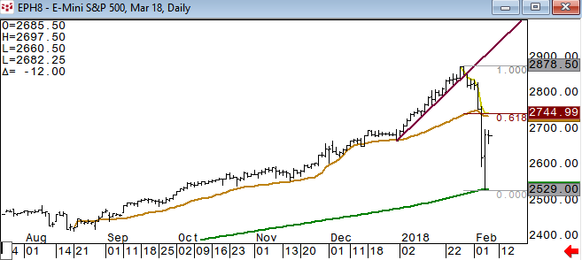
SPX pulled back approximately 38.2% of the recent decline and using this area as initial pivotal pt resistance
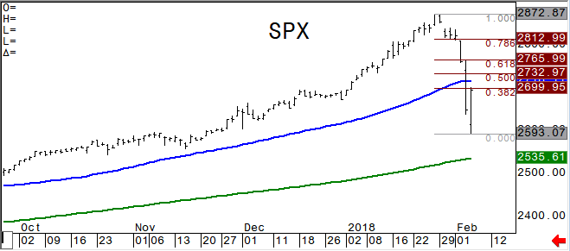
This is probably the most positive chart in the equity indices. QQQ again holding its 100dma. 163 is half way back of the recent decline and likely pivotal short term. 167.57 is the .786 retrace. NQH would likely see some weakness today below 6560. Key s/t resistance at 6747*, 6878**
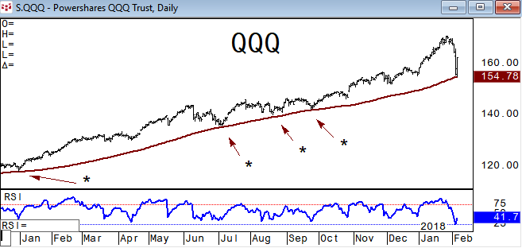
XIV announces liquidation set for later this month. ProShares assured investors the SVXY is alive and well… The Financial Industry Regulatory Authority has warned about volatility-linked ETNs, saying they aren't being properly recommended to investors. Barclays estimated Volatility Target funds will sell about $225 billion worth of stocks in the next few days to reduce their leverage – CNBC . ZIV is another one to watch as it broke its 200dma for the first time since July 2016, pulling back 50% of the move off the Feb ’16 low.
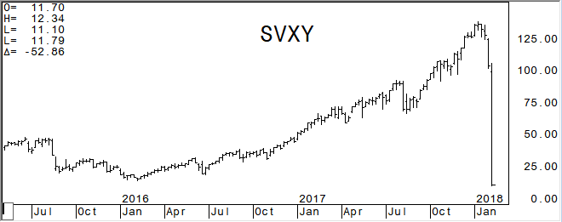
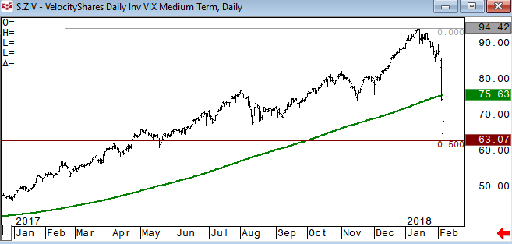
Spot Russell 2000 Index also held a key support at its 200dma. RTYH8 has initial resistance at 1517.20, 1541.20* (.618)
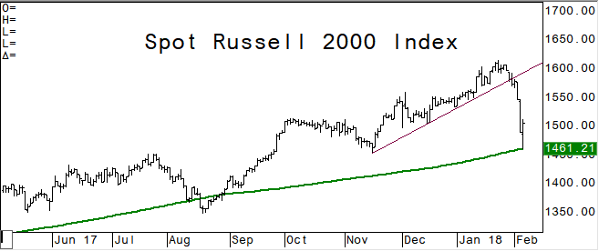
DAX future is holding a negative tone below its 200dma which has been a very good closing pivotal pt. March Eurostoxx has 3298 as long term .382 retrace and key support.
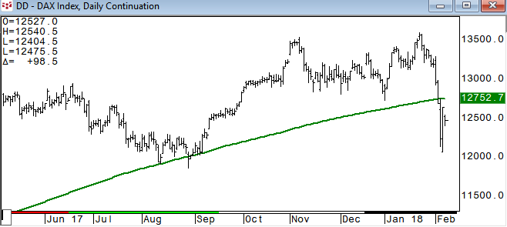
Emerging Markets – EEM held its 100dma which it has not closed below since early Jan ’17. MME (future) bounced back 50% of its recent decline at 1214 and has 1151 (100dma) as its closing key support
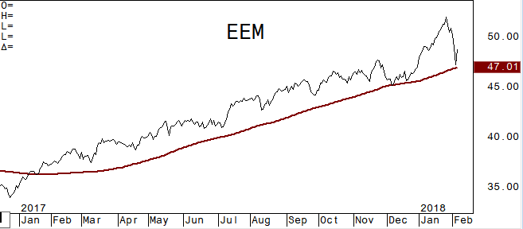
The Shanghai Composite breaks its 50dma which has been a good short term closing key. Nearly fell to the 200dma which held on multiple tests in December and should be seen as major support area.
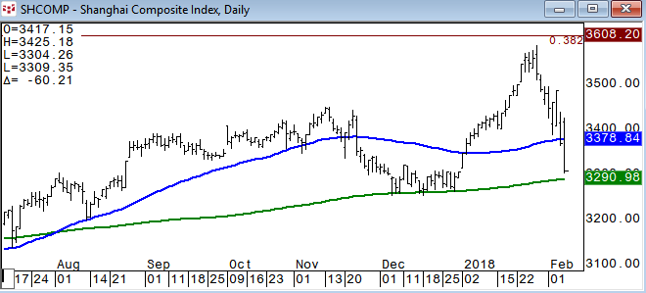
TACTICAL ALLOCATION: RELATIVE VALUE/STRENGTH
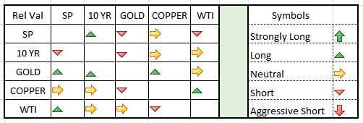
This is the relative strength, pairs trade section. Many times looking at a certain commodity relative to another can give you a perspective that you just cannot get looking at the individual. Even if you don’t trade pairs, looking at your market this way can be valuable. The above reads vertical column relative to horizontal. A little more mixed today
TLT/SPY held the short term trend line resistance yesterday and using this line as an initial key
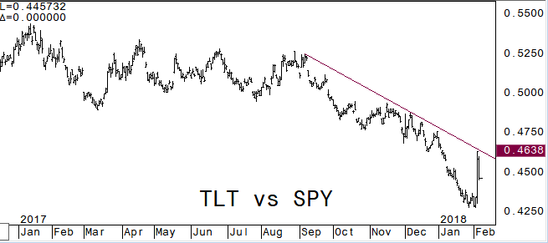
PASSIVE INVESTMENT STRATEGY: the top chart is being long TLT and SPY 50/50 split. Negative after breaking the trend line that held throughout 2017, but bounced back to the trend line. Chart two below is the weekly chart with a 60% equity/40% fixed income split. Held the two year trend line in this allocation mix.
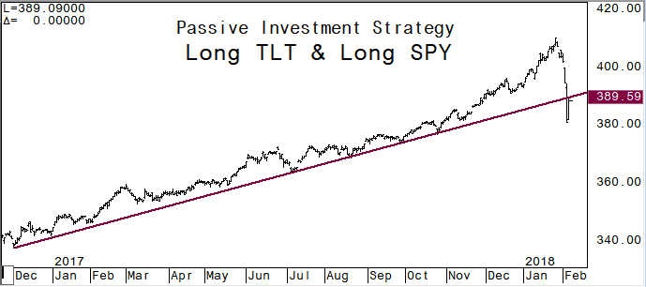
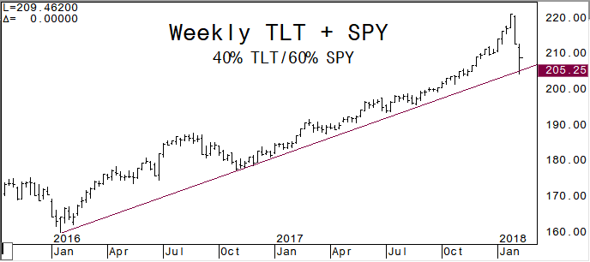
Gold vs ES: gained sharply relative to ES yesterday once above the trend line and tested the .786 retrace before slipping all the way back to the trend line which held today.
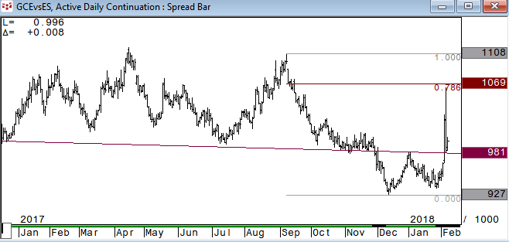
TY vs WTI was oversold and a small bounce as crude oil falters a bit. On guard for potential momentum above the trend line…
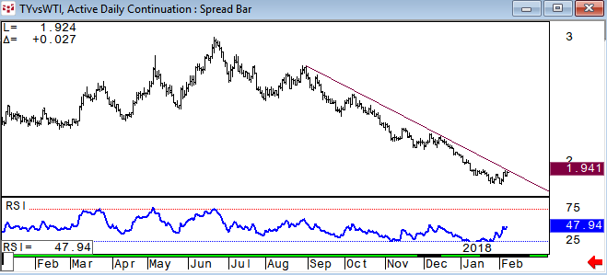
Copper vs WTI is holding potential reversal support
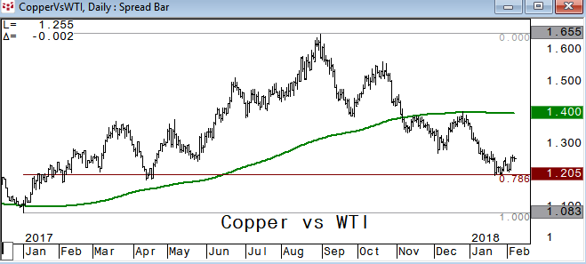
FIXED INCOME:
TYH remains negative overall below its 200 week moving average. Weekly RSI was depressed, similarly to December 2016 levels, so some pause in momentum was likely.
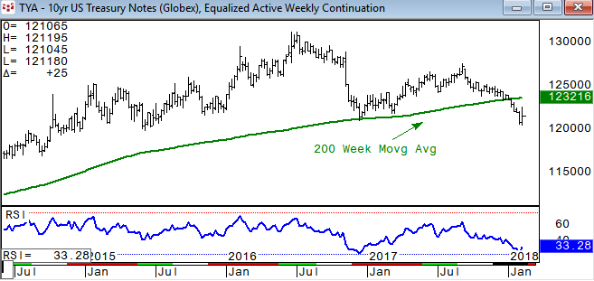
10 year yield is holding above the Dec ’16 high which is initial support in yield
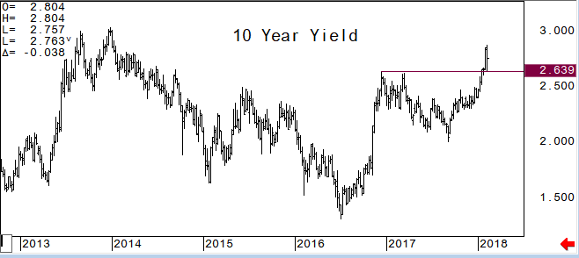
USH8: remains negative below the 200 week moving average. Short term supports at 145-14/15, 144-28. Short term resistance levels: 146-18, 147-07
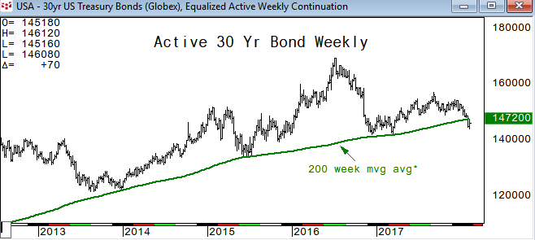
2/10 yield curve has .745% as pivotal pt. Above this level we would look for 1%, then 1.365%*; .670% is initial support area
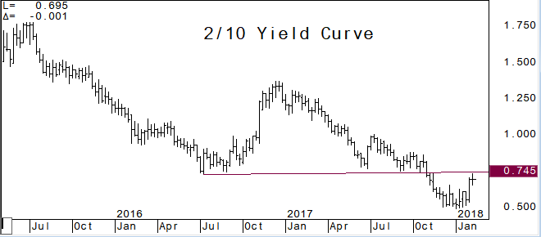
ENERGY:
March Crude Oil: negative short term below its vwap of the year, using 64.47 as s/t pivotal pt resistance. 62.63 is the .618 retrace of the year and next support. Looking for a test of the 50dma at 60.97.
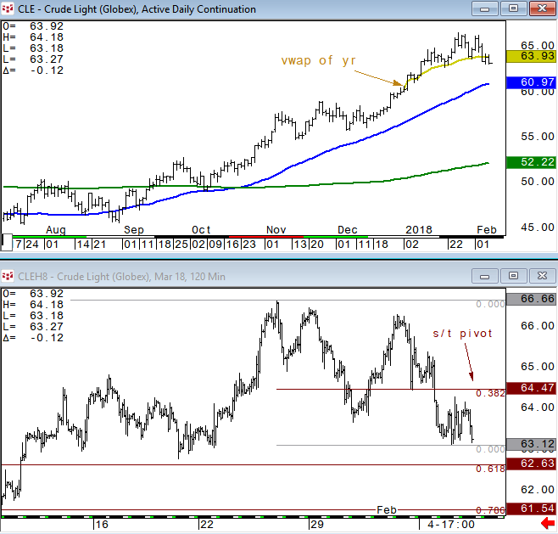
March RBOB has been underperforming crude oil and starting to roll over a bit. The .618 retrace is near the year low (1.7809) and is target/pivot.
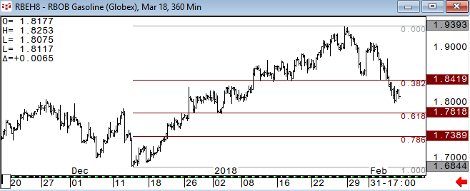
March Nat Gas has the short term .786 retracement support at 2.688. Look for this to hold for now. A clean break of this level would likely see long term .618 at 2.50*
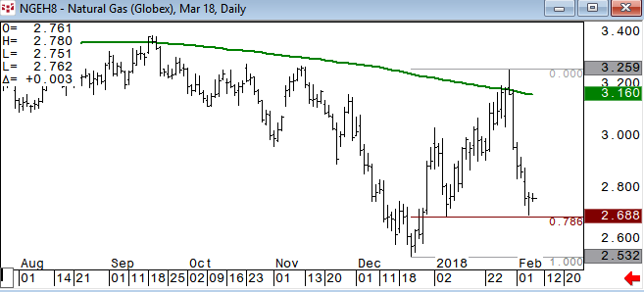
The Continuous Commodity Index is seeing key resistance around the 200 week moving average.
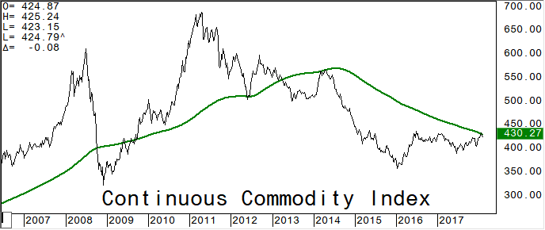
METALS:
April Gold – as actively traded contract: is holding above our initial support area of 1318-1322. CNH continues to weaken (China Renminbi strength) is the main key for gold and nearing important levels for currency chatter to disrupt.
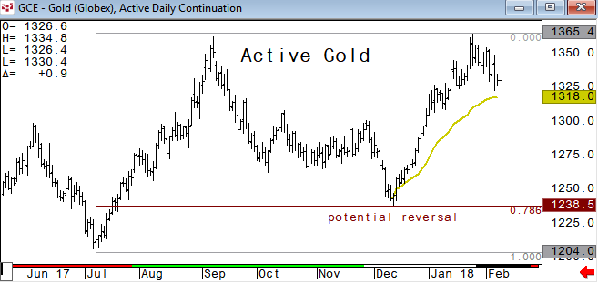
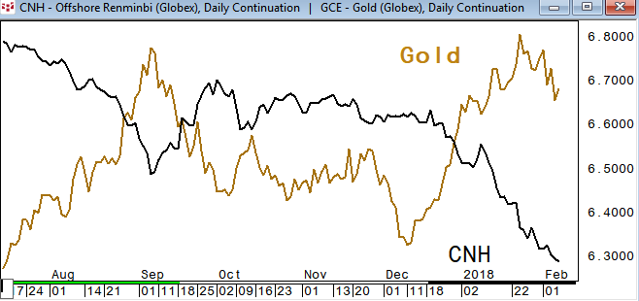
March Silver (as active contract): we have used the cloud as a pivotal area for a while and holding above the cloud is a positive. A break of 16.425 would likely see downside momentum sparked.
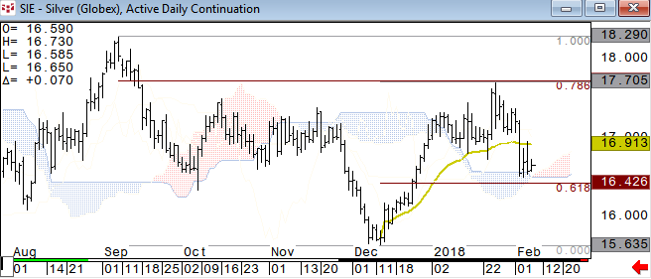
Gold vs Silver*: normally we would look for silver to be the lead in direction. The .786 retrace has been very pivotal resistance and negative for both gold and silver above the .786.
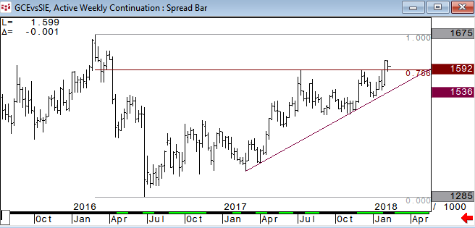
March Copper: has been choppy and short term momentum starting to roll over. A break of the little trend line would likely see it slip
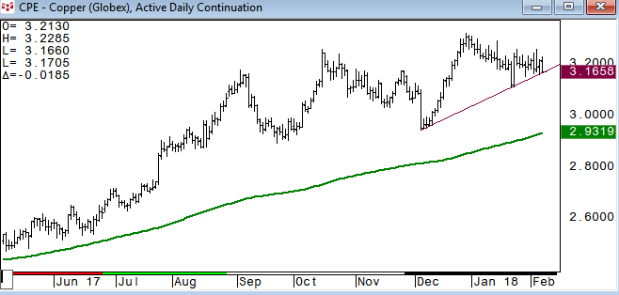
CURRENCIES:
US$ Index is holding support at its 200 month moving average and 50% retrace from the 2011 low. Starting to see some lift and we will look for a test of 90.740 and use this level as initial pivot pt resistance
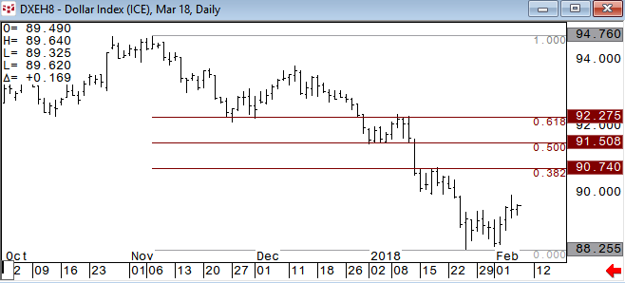
CNH lower again today and nearing pivotal levels. China must have concerns about the currency strength and we are awaiting rhetoric from them…
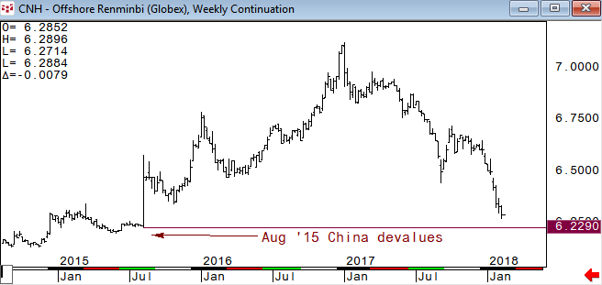
March Yen held the vwap of the year initial support area again yesterday, holding a positive short term tone
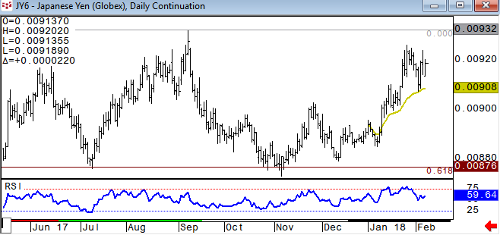
March EURUSD will likely see some downside momentum with a break of the .382 retracement
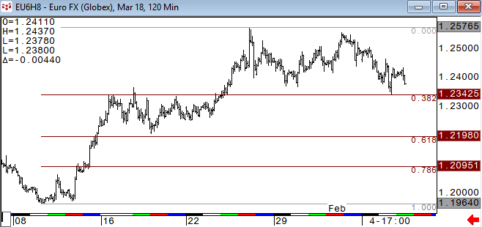
USDCAD held key support, and we are now looking for the 50dma to be short term pivotal pt. A clean break above the 50 day would likely see the 200 be tested with further momentum above it
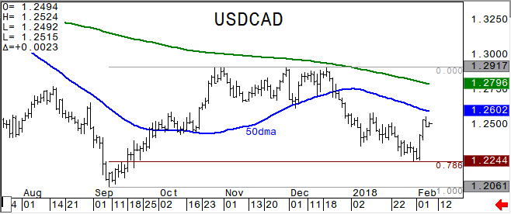

Charted using CQG
www.cqg.com

DISCLAIMER: For Educational purposes only. This is not a solicitation to buy or sell commodity futures or options on commodity futures and should not be construed as such. The risk of trading securities, futures and options can be substantial and is not for everyone. Such investments may not be appropriate for the recipient. The valuation of futures and options may fluctuate, and, as a result, clients may lose more than their original investment. Nothing contained in this message may be construed as an express or an implied promise, guarantee or implication by, of, or from Keystone Charts, Inc. that you will profit or that losses can or will be limited in any manner whatsoever. Past performance is not necessarily indicative of future results. Although care has been taken to assure the accuracy, completeness and reliability of the information contained herein, Keystone Charts, Inc. makes no warranty, express or implied, or assumes any legal liability or responsibility for the accuracy, completeness, reliability or usefulness of any information, product, service or process disclosed. PROPERTY OF KEYSTONE CHARTS, INC. DO NOT COPY OR FORWARD INTELLECTUAL PROPERTY WITHOUT PRIOR WRITTEN CONSENT.

