Today’s key technical levels in equities, rates, currencies, and commodities.
For best results in Word, click View tab then click Web Layout



February 6, 2018

TODAY’S GAME PLAN:

EQUITIES | ESH 2573 is initial key early, weakness below could see a retest of the overnight lows at the 200dma* which is pivotal in SPX. IF SPX can open flat and hold its 100dma early may be able to see a bounce. VIX and VIX ETNs are the key today; VIX nearing 2015 high. 1406 area is initial key in RTYH. QQQ has 154.60 (100dma) as pivotal support.
RATES | USH8 tests the 200 week mvg avg* of 147-20 key resistance. TYH has year vwap at 122-12 and closing pivot. 2.64% is pivot pt support in 10 yr yield. USH vs ESH is positive, but the passive investment strategy charts are negative
ENERGY | CLH8 should see some weakness from equities. Negative below the yr vwap and look for 60.89 50dma as target. Brent neg below 67.70 today looking for 65 handle. RBOB neg below 1.8420 with 1.7820 initial target and pivot. Nat Gas has 2.6888 as s/t .786 and pivotal s/t. 2.5 major support below
METALS | Gold has been holding a positive tone, even with silver weakness. US$, CNH weakness the keys. SIH8 holds cloud support, but needs a clean break and settle above 16.925. Copper is mixed
CURRENCIES | US$ is holding above long term key support, but lacks any momentum. CNH lower again is a highlight to watch. Yen holds vwap support and rallies on safe haven trade. USDCAD nearing its 50dma which is s/t pivotal pt (CA^ 79410).
TRADE IDEAS:
New Ideas:
Date | Commodity | Buy | Sell | Stop | Target | Notes
2/6 | CLH8 |  | 63.90 | 64.60 | 60.89 | Below vwap of yr
 | ESH |  | <2573 |  | 2531 | 200dma is key
DATA and HIGHLIGHTS: 8:30 ET International Trade; 8:50ET Bullard speaks; 10:00ET JOLTS; 1:00ET 3 Yr Note Auction
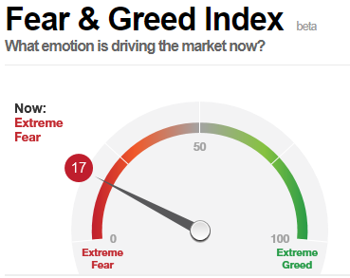
XIV -90% overnight; the threshold for an XIV termination event is a -80% drop. Credit Suisse said late Monday New York time that the XIV's plunge would have no "material impact" on the bank itself LINK. NYSE ARCA HALTS PROSHARES SHORT VIX SHORT-TERM FUTURES ETF. CS says they had no trading loss from XIV.
 | ESH8 | TYH8 | GCJ8 | CLH8 | DXH8
Resistance | 2703.75 | 123-21+ | 1380/81* | 67.75 | 92.320
 | 2663/68 | 123-08+* | 1370.5 | 66.89 | 91.650
 | 2646.00 | 122-23+ | 1362.0 | 66.46 | 90.740*
 | 2634/36* | 122-12vwap | 1355.0 | 65.37 | 90.000
 | 2626.00 | 121-18 | 1345.5 | 64.58 | 89.560
Settlement | 2607.75 | 121-08+ | 1336.5 | 64.15 | 89.405
 | 2595.00 | 121-06+ | 1330.0 | 63.93close | 88.250
 | 2573.00 | 120-28 | 1321.5* | 63.29 | 88.000
 | 2553.75 | 120-18 | 1306.6 | 62.55/65 | 87.100
 | 2531.00* | 119-28* | 1300.0 | 61.54 | 86.870
Support | 2500.00 | 119-10 | 1291.0* | 60.89 | 84.680*
Colors within the report: Green is always the 200 period (day, week, etc.). Red is always 21, Blue = 50, Brown = 100, Yellow is vwap. *Stars have more emphasis, meaning 2 or more technical pts line up
EQUITIES: Dow Jones Industrials Average saw its biggest point move ever falling almost 1,600 points intraday.
This has been our concern for a derailment of equities. The passive investment strategy using 30 yr bond and ES broke the trend channel (more on this in Tactical section below)
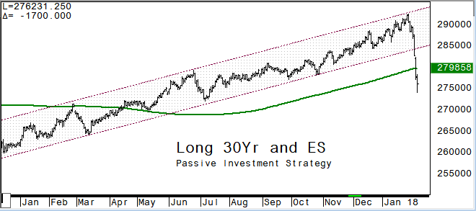
ESH8: falls -12.14% from its high and hits the 200dma overnight. The 100dma at 2635 area will be the initial key resistance area during the day session (see SPX)
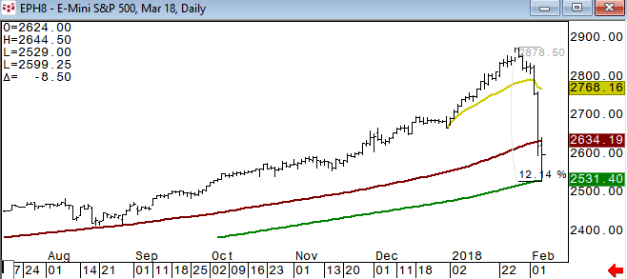
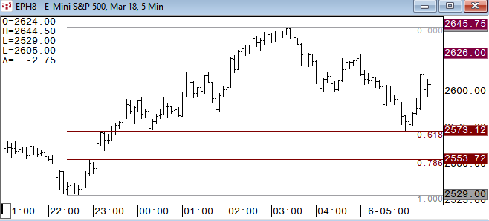
SPX has its 100dma at 2633 and we will use that level as initial key (resistance today). The 200dma in SPX is 2533* which held as pivotal support in November 2016. This will be the major focus to start today
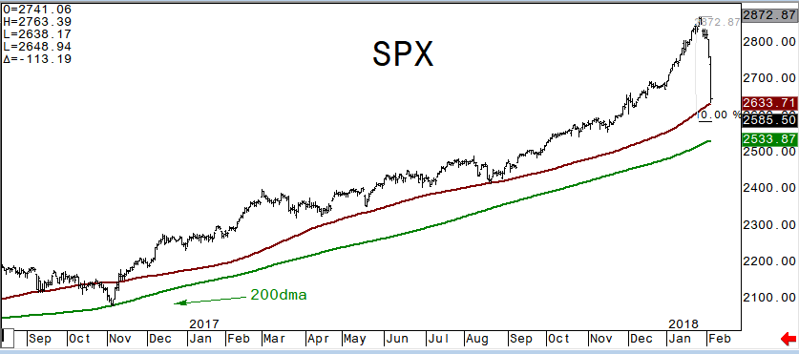
VIX nearing the 2015 high - XIV down -84% overnight; there is a ‘termination’ trigger in XIV that permits the underwriter, in this case Credit Suisse, to liquidate the fund in order to prevent a negative equity situation.
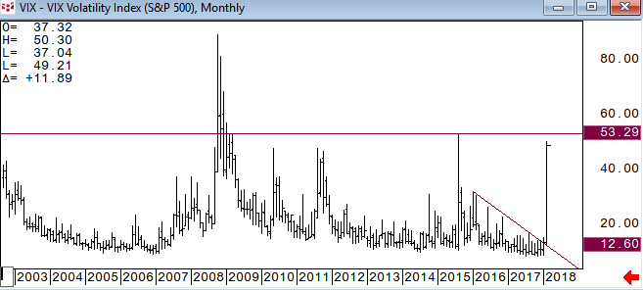
XIV overnight price action (chart via MarketWatch.com)
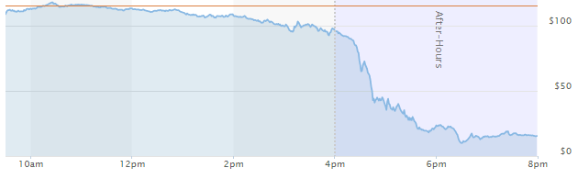
NQH traded below its 100dma overnight, which had held as pivotal support a few times in 2017.
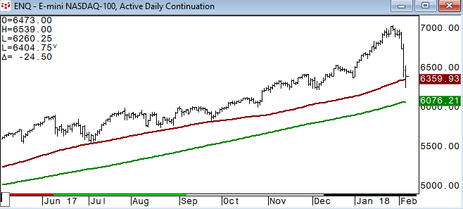
The 100dma in QQQ held on several touches in 2017 is at 154.62 and has some room before that is tested.
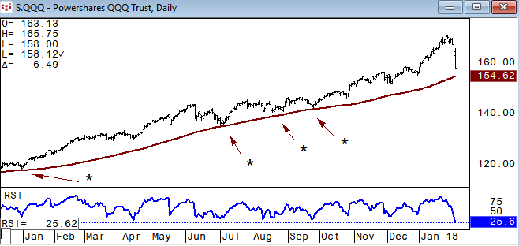
March Russell 2000 has 1406.50 as next key support . IWM settled on its 200dma and will see momentum today below it. 135 is the .382 retrace from the 2016 low.
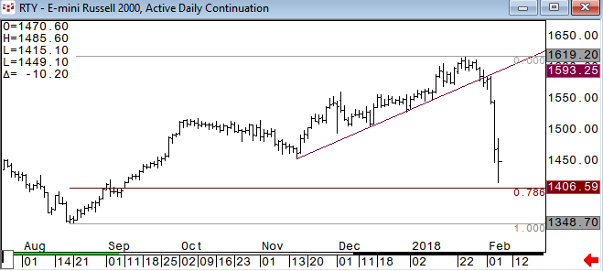
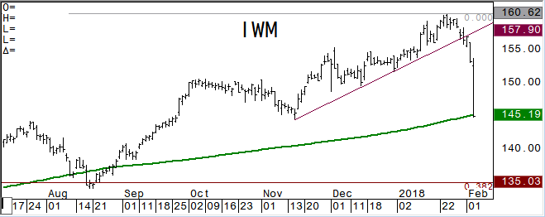
DAX future is holding a negative tone below its 200dma which has been a very good closing pivotal pt. March Eurostoxx has 3298 as long term .382 retrace and next key support.
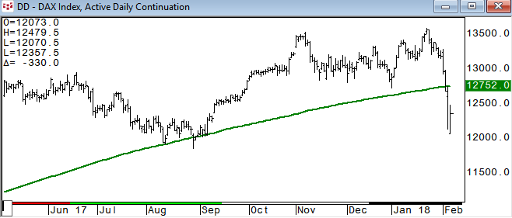
Emerging Markets – MME has 1150 (100dma) as its closing key support
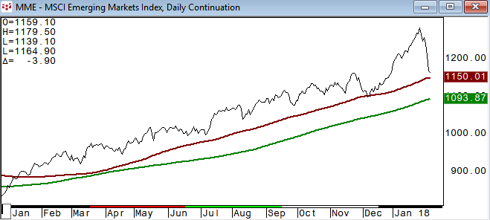
The Shanghai Composite breaks its 50dma which has been a good short term closing key. Next stop is a retest of the 200dma which held on multiple tests in December.
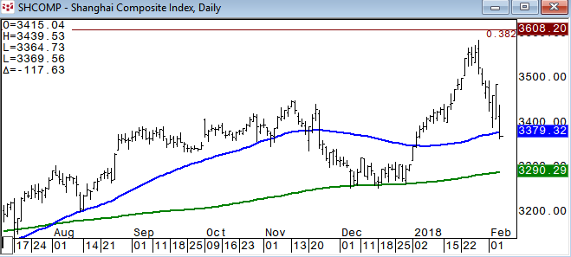
TACTICAL ALLOCATION: RELATIVE VALUE/STRENGTH
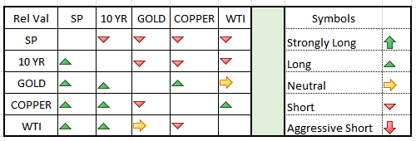
This is the relative strength, pairs trade section. Many times looking at a certain commodity relative to another can give you a perspective that you just cannot get looking at the individual. Even if you don’t trade pairs, looking at your market this way can be valuable. The above reads vertical column relative to horizontal. ES turning negative relative to the other asset classes.
USH8/ESH8: long bond outperforming this week and back above the 50dma and trend line. Positive above this level for now with a test of the .786 likely.
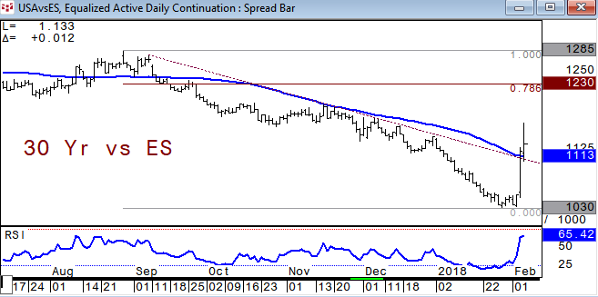
This is what we were concerned about; the passive investment strategy unwind. Long both, 10 year future and ES breaks the year plus long trend line yesterday. The weekly trend line in TLT+SPY will be the next key and major support
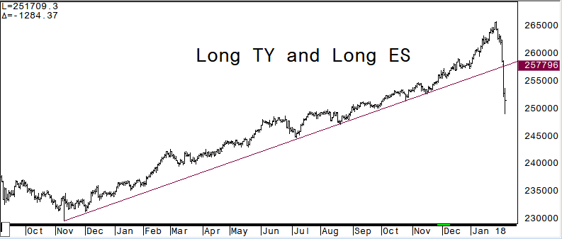
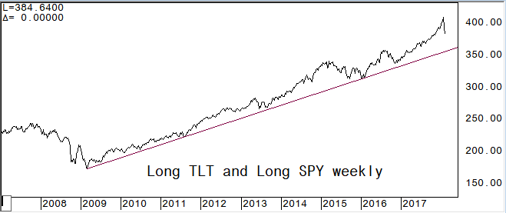
Copper relative to WTI is firming after holding pivotal support and we look for further outperformance from copper
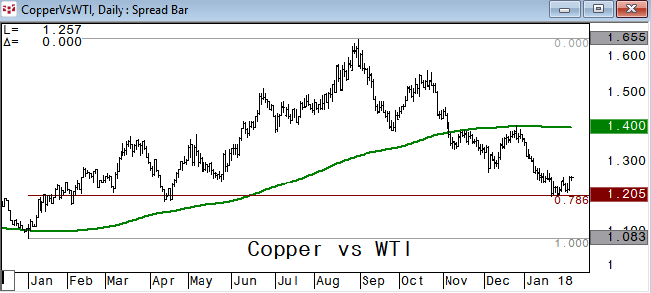
Gold vs ES: gained sharply relative to ES yesterday once above the trend line and tested the .786 retrace overnight before slipping back.
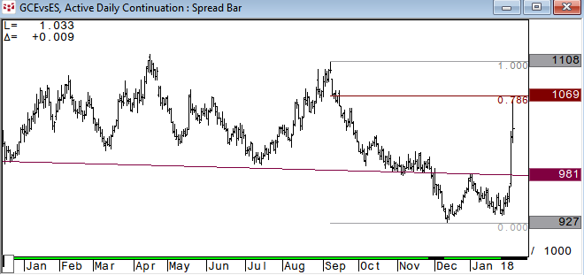
Gold vs WTI starting to inch above the short term trend line as gold outperforms
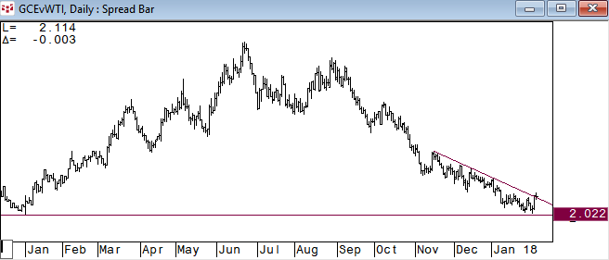
WTI vs ES: crude oil remains positive relative to equities
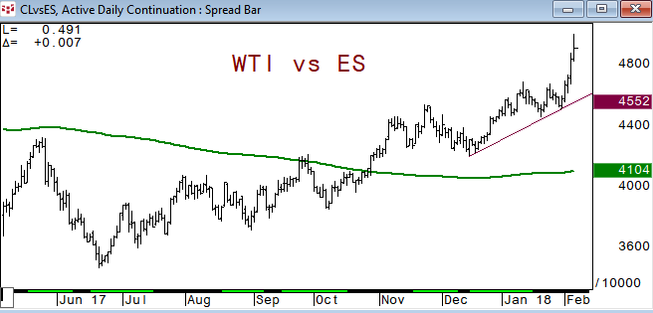
FIXED INCOME: what would slow the pace of Fed rate hikes? A sharp sell-off in equities would be one
TYH remains negative overall below its 200 week moving average. Weekly RSI was depressed, similarly to December 2016 levels, so some pause in momentum was likely.
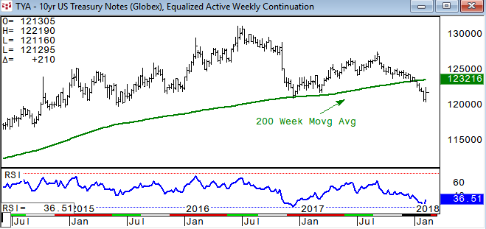
10 year yield is holding above the Dec ’16 high
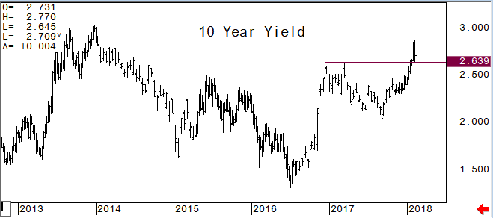
USH8: traded just slightly above the 200 week moving average overnight, and we look for this area to hold as pivotal resistance. 145-25 is initial support with renewed downside momentum likely below it
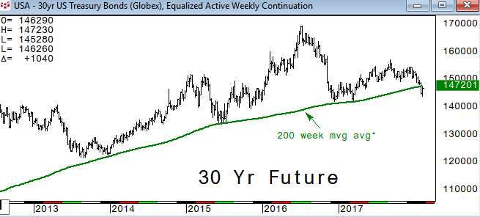
2/10 yield curve has .745% as pivotal pt. Above this level we would look for 1%, then 1.365%*; .675% is initial support
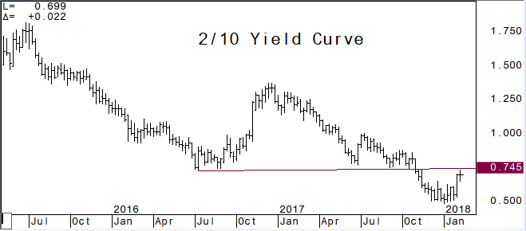
ENERGY:
March Crude Oil: we were looking for the 200 month moving average to be an area of pause for WTI. Traded below the vwap of the year yesterday and will be short term negative with settles below it for now. 62.63 is the .618 retrace of the year. Could see a slip below here to test the 50dma at 60.89
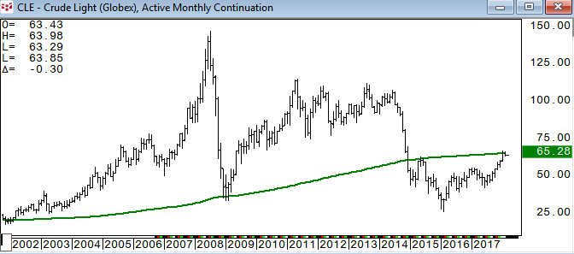
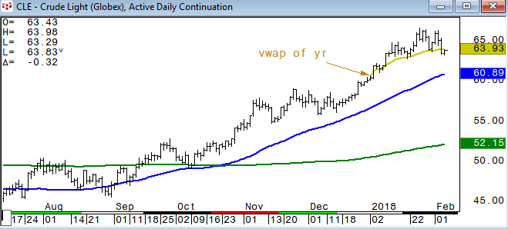
Brent Crude is lower again and testing its .786 retrace of the year.
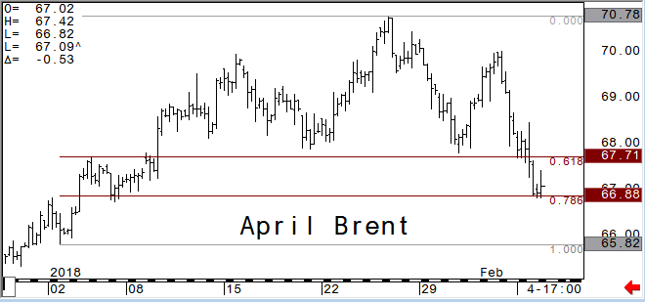
March RBOB has been underperforming crude oil and starting to roll over a bit after breaking the short term trend line. Negative below 1.8420 with next support at 1.7818 (s/t .618)
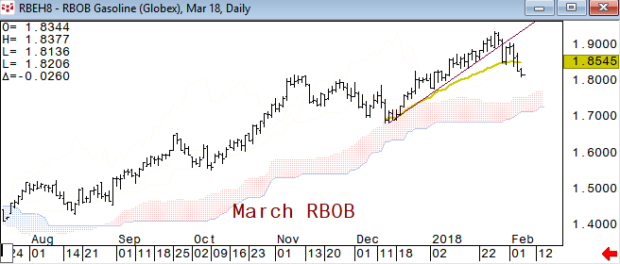
March Nat Gas has the short term .786 retracement support at 2.688. Chart two below is the weekly rolling front month view and shows the 2.50 area as very pivotal support below.
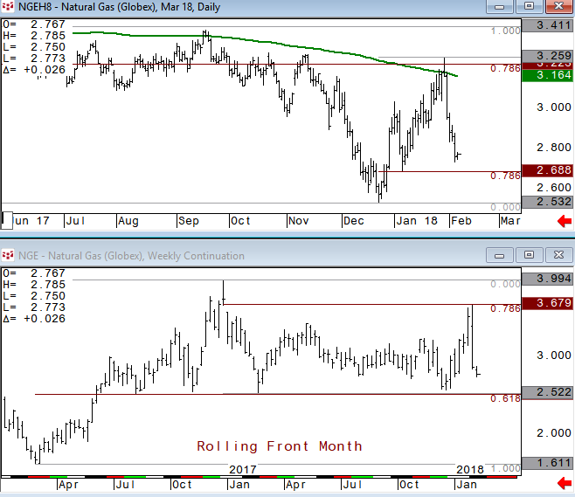
The energy sector has been underperforming the last two weeks and all three ETFs are nearing their 200 day moving averages.
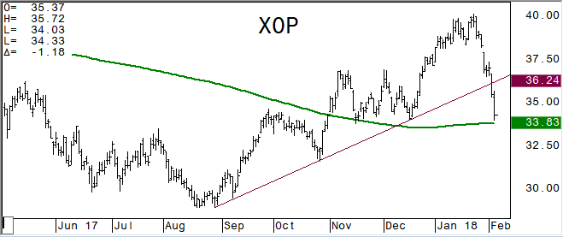
METALS:
April Gold – as actively traded contract: is higher today and remains positive, but vulnerable as silver underperforms.
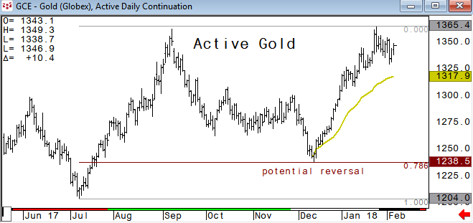
March Silver: we have used the cloud as a pivotal area for a while and holding above the cloud is a positive. A break of 16.425 would likely see downside momentum sparked.
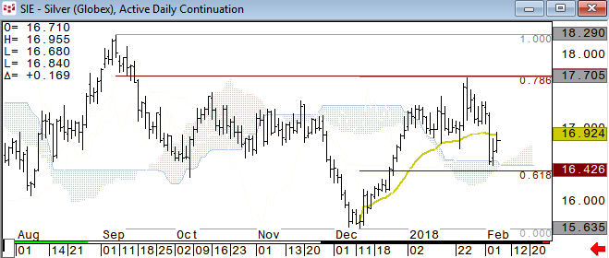
Gold vs Silver*: normally we would look for silver to be the lead in direction. The .786 retrace has been very pivotal resistance and negative for both gold and silver above this pivotal point.
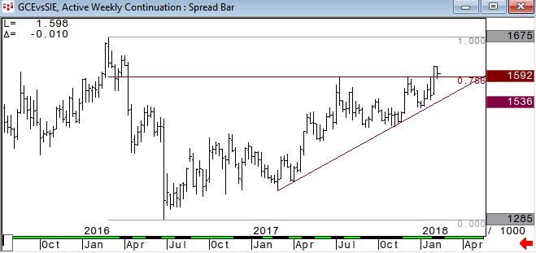
March Copper: has been choppy and we will use the 3.0875 area below as short term pivot pt
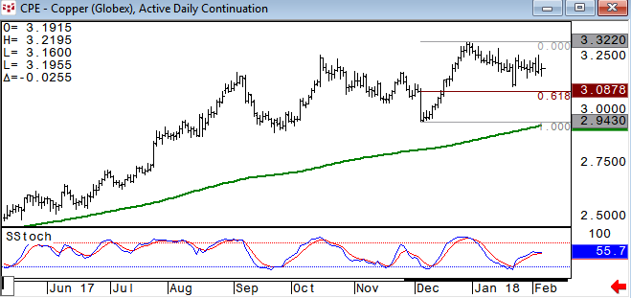
CURRENCIES:
US$ Index is holding support at its 200 month moving average and 50% retrace from the 2011 low.
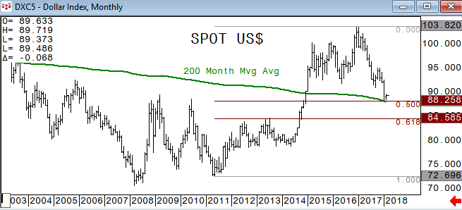
CNH lower again today and nearing pivotal levels
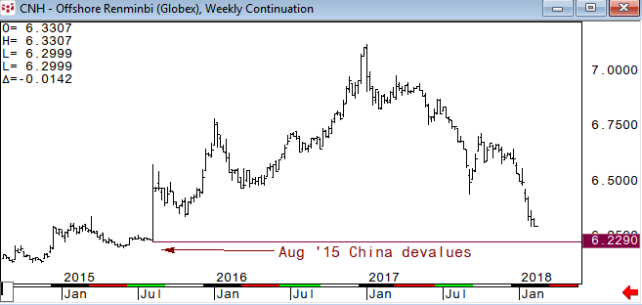
March Yen held the vwap of the year initial support area again yesterday, holding a positive short term tone
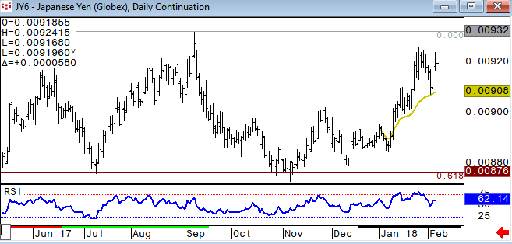
CA6 turned lower after testing the .786 resistance and is nearing the 50dma which has been a very good short term pivotal pt. We will look for this level to hold, but if it breaks look for a retest of the 200dma* (50dma in USDCAD is 1.2606).
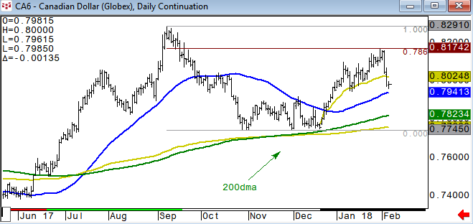
Charted using CQG
www.cqg.com

DISCLAIMER: For Educational purposes only. This is not a solicitation to buy or sell commodity futures or options on commodity futures and should not be construed as such. The risk of trading securities, futures and options can be substantial and is not for everyone. Such investments may not be appropriate for the recipient. The valuation of futures and options may fluctuate, and, as a result, clients may lose more than their original investment. Nothing contained in this message may be construed as an express or an implied promise, guarantee or implication by, of, or from Keystone Charts, Inc. that you will profit or that losses can or will be limited in any manner whatsoever. Past performance is not necessarily indicative of future results. Although care has been taken to assure the accuracy, completeness and reliability of the information contained herein, Keystone Charts, Inc. makes no warranty, express or implied, or assumes any legal liability or responsibility for the accuracy, completeness, reliability or usefulness of any information, product, service or process disclosed. PROPERTY OF KEYSTONE CHARTS, INC. DO NOT COPY OR FORWARD INTELLECTUAL PROPERTY WITHOUT PRIOR WRITTEN CONSENT.

